Link to game in Roll20 is https://app.roll20.net/join/1584953/gSIcMQ

Starting Point Map

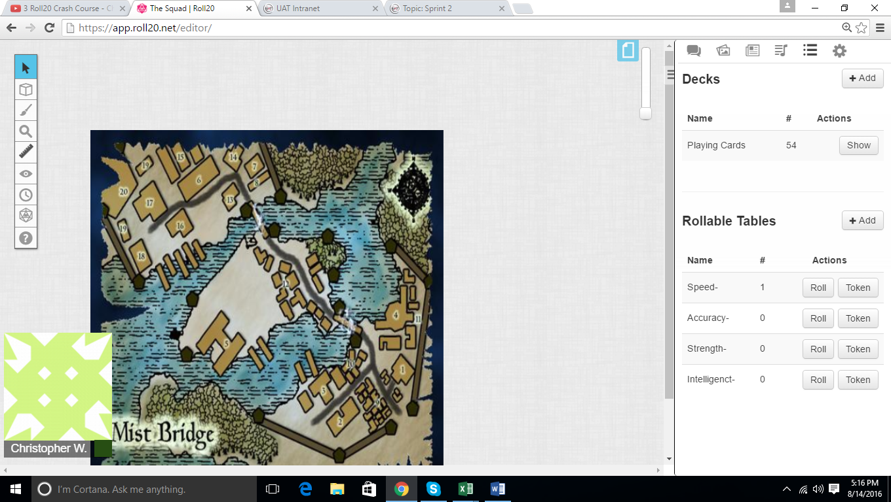

Building One Map

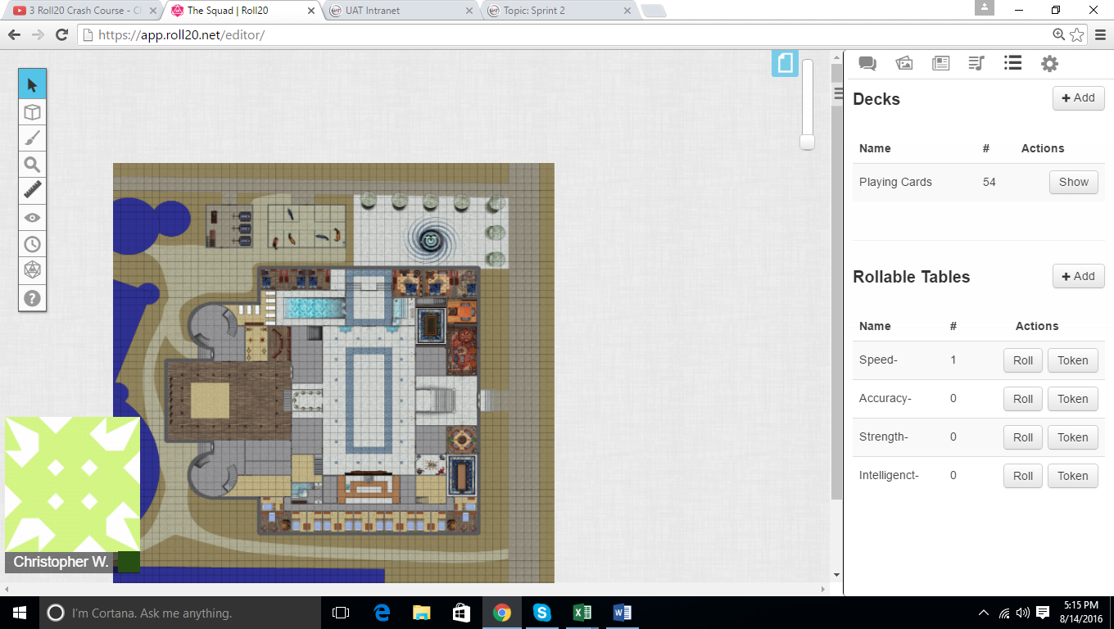

Players built with Starting Scenario programmed in. Players decide on their own starting stats

